1. Write some test cases to test a sample hadoop word count program using MRUnit

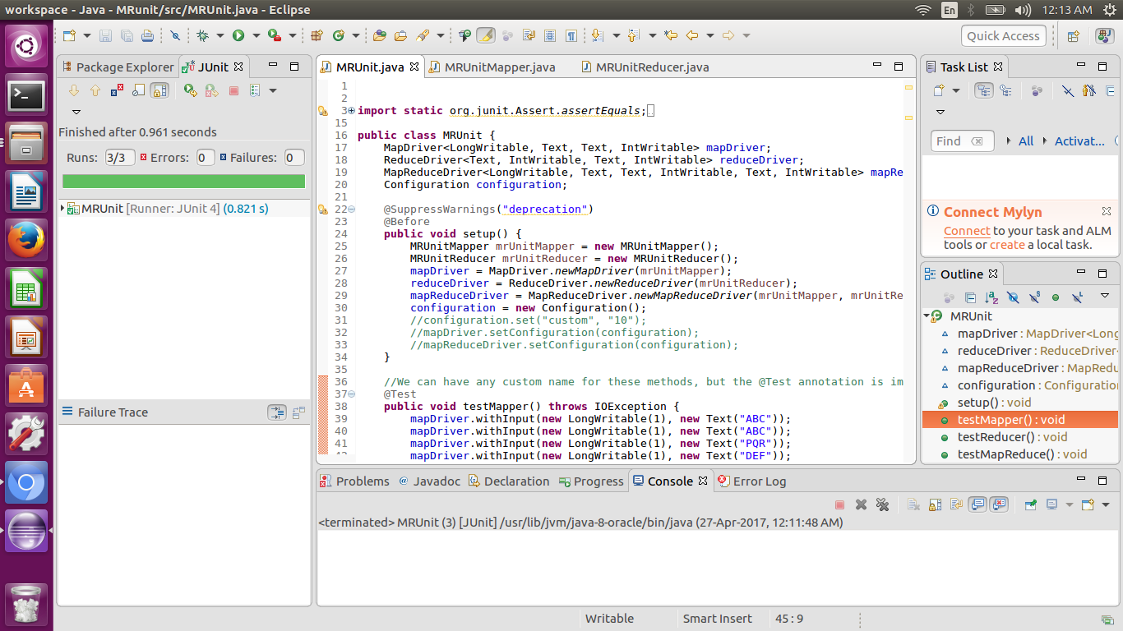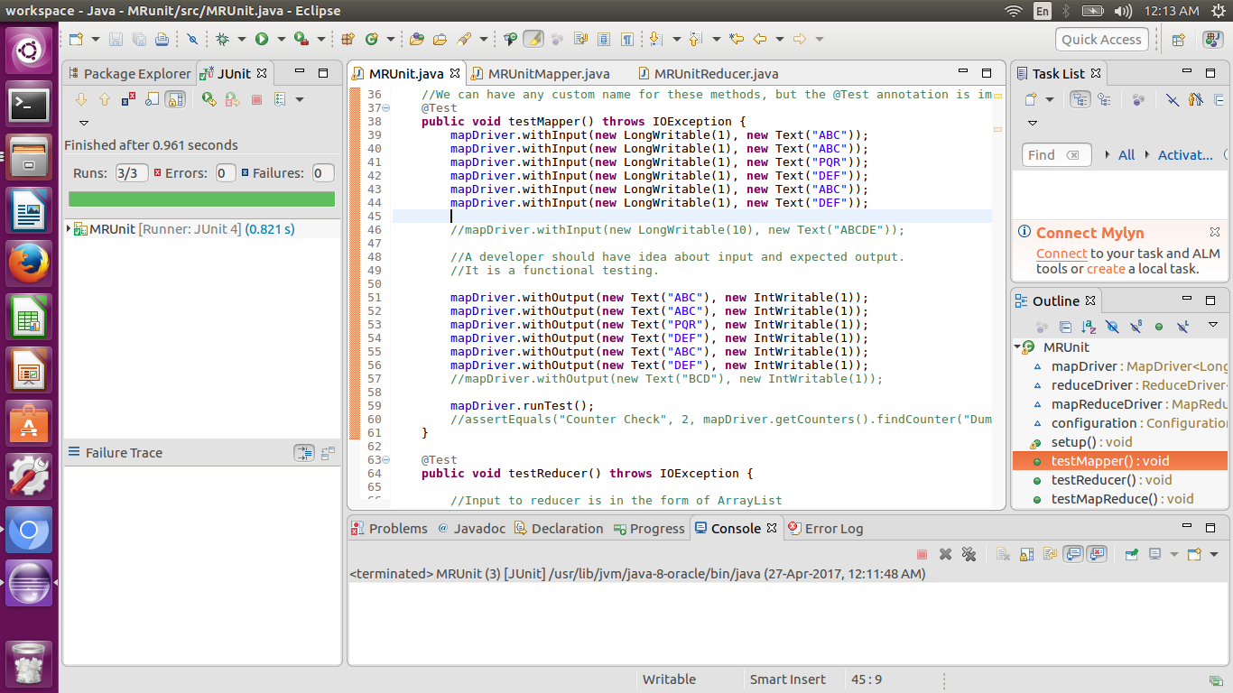

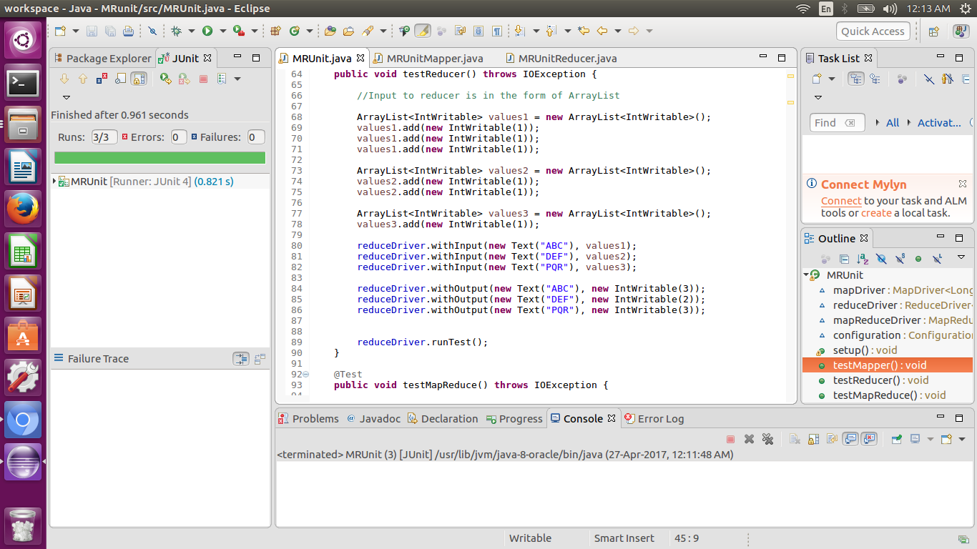

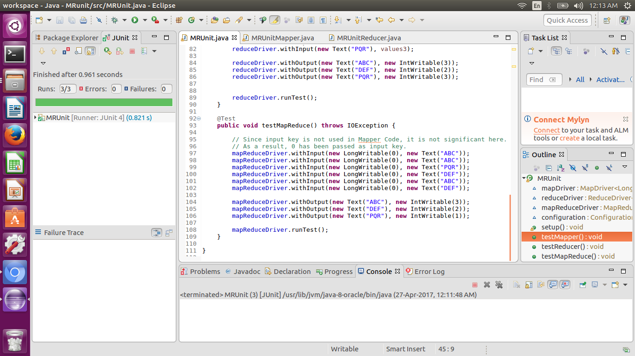

Types of MRUnit Tests

1. A map test that only tests a map function (supported by the MapDriver class).
2. A reduce test that only tests a reduce function (supported by the ReduceDriver class).
3. A map and reduce test that tests both the map and reduce functions (supported by the MapReduceDriver class).

**Map driver:**

Map Driver Harness allows you to test a Mapper instance. You provide the input (k, v)* pairs that should be sent to the Mapper, and outputs you expect to be sent by the Mapper to the collector for those inputs. By calling runTest(), the harness will deliver the input to the Mapper and will check its outputs against the expected results. We will be testing the classic wordcount code.